**1.**

<http://fieldpapers.org/atlases/3ylen0sc>

**2.**

This block in the International District is probably the place I’ve been to the most (in the International District) throughout my life. One of the restaurants there, Jade Garden, serves probably the best dim sum available in Seattle and it is my family’s go to place for small reunions. I’m very “far” from the place as well because if I’m driving my family there, I never know where to park. I also find that I only know the approximate locations of places, but not the exact locations. My influence on this map will be that I’m mostly familiar with restaurants, which I will map, but any other places I don’t go too often, including medicine shops, probably won’t make it to the map.

**3.**

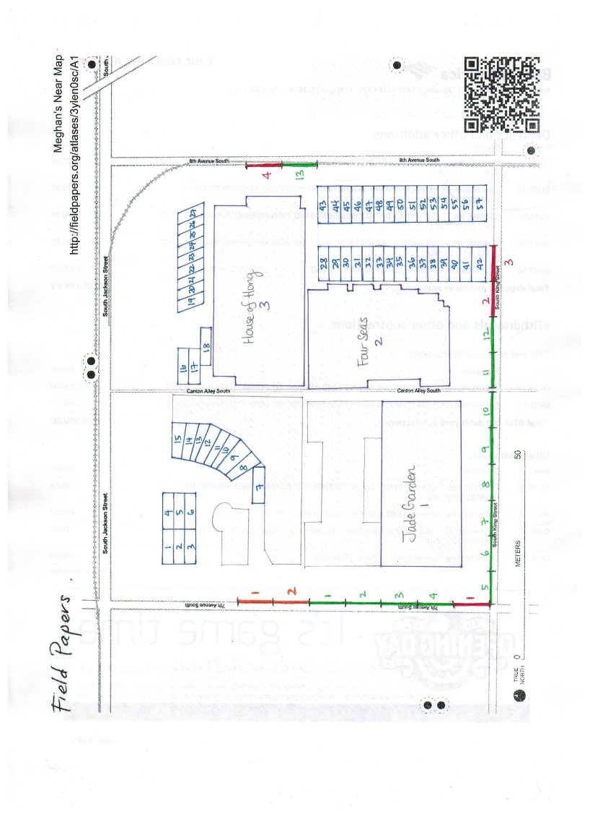

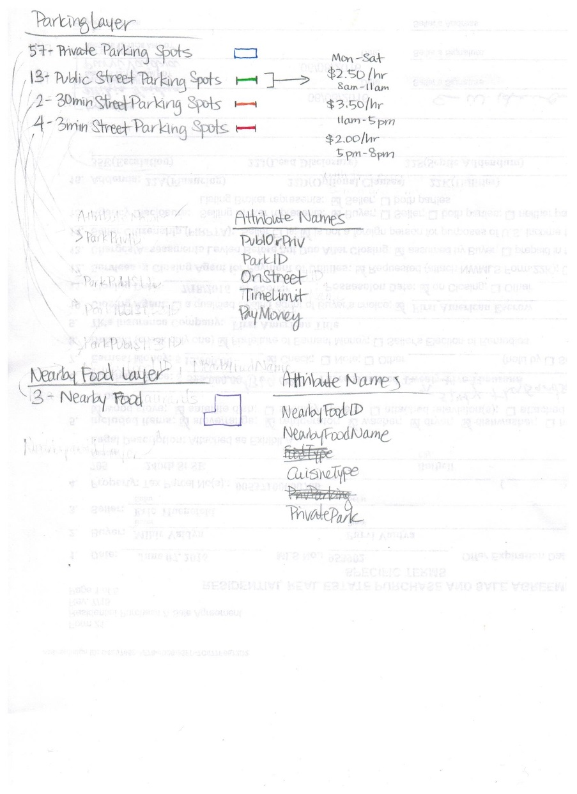

**4.**

<http://tiles.fieldpapers.org/snapshots/ooukc198/$z/$x/$y.png>

**5.**

NearbyFood Layer

<https://gist.github.com/anonymous/bcf1d5907947f9b8843ef9e48e8b15fd>

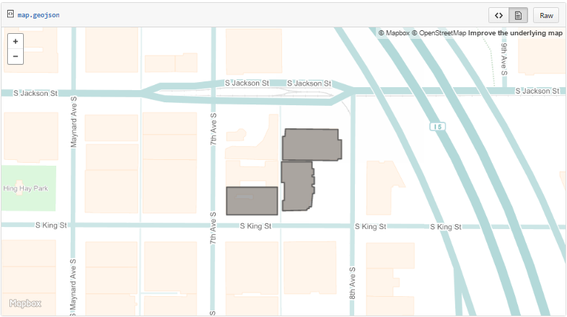

Parking Layer

<https://gist.github.com/anonymous/2dfa1a514d6969d0e8ad5ccac2218d4c>

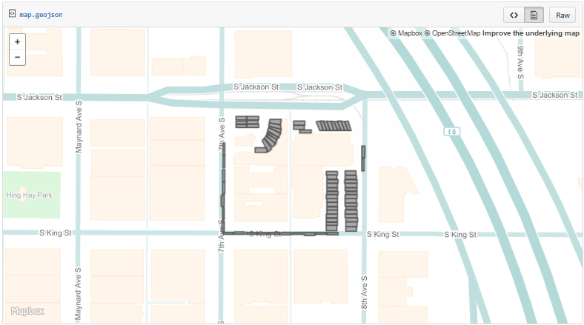

**6.**

<https://gist.github.com/anonymous/2e25acf37fb475429361658295b8dfeb>

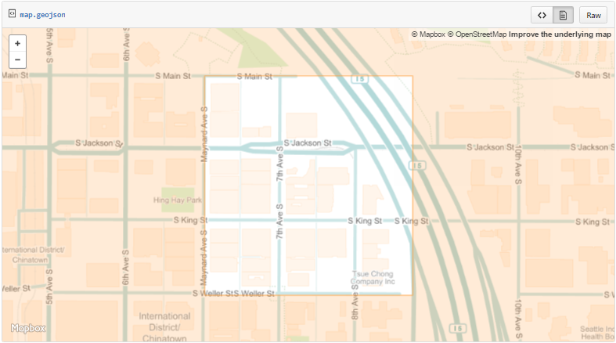

**7.**

<http://arcg.is/2fP9xGo>

**8.**

<https://uw-geog.maps.arcgis.com/apps/MapSeries/index.html?appid=606a683ffded4bccace4018a19643d3e>

**9.**

When I was mapping the “far” data, I found that I could only map buildings and prominent roads, but I couldn’t give a name to those features because I didn’t live there, which frustrated me. However, when I found that I could map the data “near” to me, I only chose the buildings and other features that were familiar to me which was peculiar (I would probably map more buildings if I could make more layers, though). One more dichotomy was that I found myself mapping at least a hundred “far” buildings for the sake of the cause, but drawing the outlines of the buildings for “near” buildings required a lot of patience due to the detail that was readily available to me. Overall, I felt interestingly more intrigued to be mapping a new and far place, than a place close to home, probably because there is a sense of exploration when doing so.